Steps To Execute the test:

1. Make sure you have Node(Any version) installed in your system
2. Next install VS Code
3. Open VS Code and open the file API-NodeJs

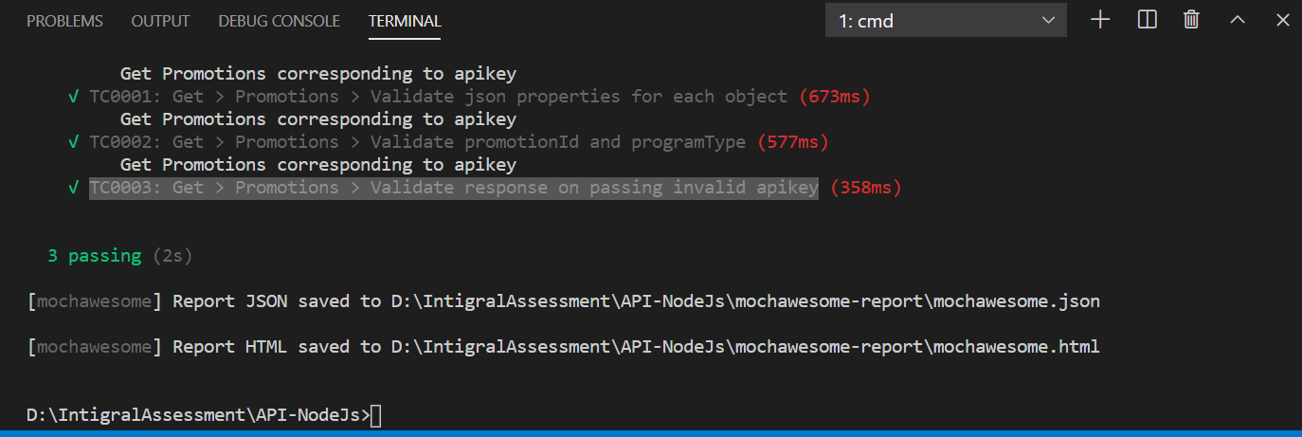

1. Type in **npm init** and press enter (Refer above snapshot)
2. Type in **npm install** and press enter
3. Type in **npm install chai, chai-uuid, config, cross-env, json-beautify, mocha, mochawesome, request, supertest** and press enter
4. **To execute:** Type in **npm run test-qa-internal** and press enter
5. **To see the report:** Left side menu, look for report, open it in google chrome (Else go to Project directory and click on API_report.html)